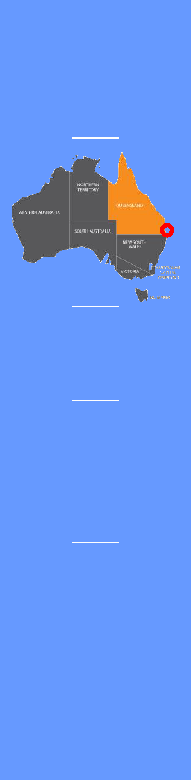

QBT is a bulk storage and handling facility with the capacity to sample, test, receive, store, pack and ship a range of grains and liquids. These include, but are not limited to wheat, sorghum, maize, pulses, tallow, edible oils, and propylene glycol (industrial).

The QBT facility has over 85,000 metric tons of bulk grain storage, over 10,000 metric tons of bulk liquid storage, two all-weather grain receiving stations, a container packing facility, and a ship loader.

Please read the following information carefully before completing the acceptance section on page 7.

**Brisbane Queensland Australia**

**27°28′04″ S 153°01′41″ E**

**Silo Storage**

**5,200mt**

**Shed Storage**

**85,000mt**

**800,000 tonnes per annum**

156 Colmslie Road

Murarrie Qld 4170

Ph: 3902 0350

**Port Information**

|  |  |  |  |  |  |
| --- | --- | --- | --- | --- | --- |
| **Name of Port:** | Brisbane |  | **Port Code:** | AUBNE |  |
| **Time Zone:** | GMT + 10 (Brisbane does not have daylight saving in Summer) | | | | |
| **Charts:** | AUS Charts 235, 236, 237 and 238 | | | |  |
| **Pilot boarding:** | Pilot boards by launch only, 24 hrs a day, 7 days a week, year-round | | | | |
| **Harbour Control VHF:** | Channel 12 – monitored 24 hrs 7 days | | | |  |
| **Approach channel depth:** | 9.10 m Chart Datum (nominated depth) | | | |  |
| **Swing Basin off berth:** | 9.10 m Chart Datum (nominated depth) | | | |  |
| **Tidal information:** | **HAT:** | 2.73m | **MHWS:** | 2.17m | MHWN: 1.78m |

**Terminal Information**

**Berth Operator:**

**Berth Name:**

**Establishment Number:**

**ABN:**

**ACN:**

**Berth location:**

**Berth Pocket – Length:**

**Berth depth:**

**Maximum – LOA:**

**Port Services:**

**Berthing direction:**

**Loader descriptions:**

**Loader Rate – Max:**

Queensland Bulk Terminals Pty Ltd

Queensland Bulk Terminals Pty Ltd

1153

89 138 437 260

138 437 260

About 8nm upriver in the Hamilton reach

270.00m **Width:** 35.00m

10.0m (chart datum) **Density:** 1.020 – 1.024

230.00m (maximum) **Beam:** Less Than 33.00m

**Towage:** 2 in / 2 out **Lines Launch:** 1 in / 0 out

Tankers may berth Port or Starboard side to

General Cargo Ships Starboard side-to, head down

The loader is a single mobile gantry with horizontal travel.

1,000 mt per hour **Average:** 750 – 900 mt per hour

**Max sailing drafts:** **Draft < 8.5m** Vessels can berth / sail at any time.

**Draft 8.5m -10.1m** Vessels should be able to berth / sail on a tide on any given day of the year.

**Draft >10.10m** Are possible but are not guaranteed and the deeper the draft up to / abt 10.50 m the less likely a tide will be available.

In considering the draft of the vessel sailing from QBT vessel operators should also take into consideration that this berth is shallow with only **10.0m** alongside and a **UKC of 0.30m** must be maintained at all times (to calculate max draft alongside = 10.0m less UKC (0.30) + tide).

**Cargo Stowage factor:** Variable subject to cargo / grain type being loaded

**Working arrangements:** 24 hrs a day, 7 days a week, year-round.

**Berth Diagram:**

*Approximate Measurements:*

Front edge of wharf length overall **158m**

Downstream dolphin to downstream berth edge **36m**

Downstream dolphin to upstream dolphin **274m**

Shiploader maximum travel = **130m** bumper to bumper

**Tie Up Diagram:**

**Air Draft Restrictions**

Loading Arm: Maximum of 15° is permitted when loading. (At 15.1° the belts will auto stop)

Arm can lift to a maximum 27° to gain access to ship only. (Belts must be stopped and empty)

**Topping off Holds:**

Maximum height for topping of holds is 11500mm above Hat. (Chute fully retracted)

Log rails are usually required to be folded down to be within above limits.

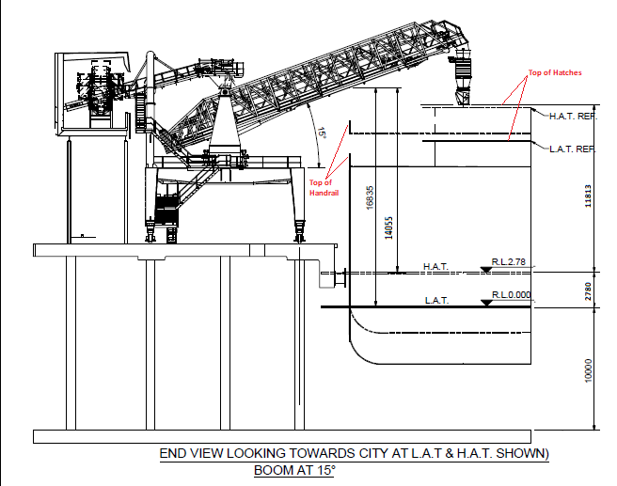

**Berthing velocities PIANC**

The following table has been used to extract PIANC values for Berthing velocity by vessel DWT for

the Good Sheltered Conditions considered for the Berth.



**Extreme Scenario**

Berthing Test scenario run at 10cm/sec for 85,000 DWT.

Vessel. 85,000DWT, 228m long, 32.9m wide, 45,000 t displacement on arrival

85,000 DWT vessel with the scenario presented of a combination of the following unlikely cases.

* Berthing velocity of 10cm per second.
* Berthing at an angle of 7 degree to the forward fender.
* Distance from bow to point of impact 19 percent.

This will deliver a normal energy of 146.52 kNm to the forward fender. The fender has a capacity in

excess of 205kNm.

**Expected Upper Bound of Arrival Conditions**

35,000t displacement on arrival

* Berthing velocity of 6cm per second. (4cm PIANC)
* Berthing at an angle of 3 degree to the forward fender.
* Distance from bow to point of impact 14 percent.

Normal Energy 31.05 kNm with fender capacity in excess of 205kNm.

**Casual Berth Charges**

Pricing Effective 1st Oct 2024

Privately owned and operated facility. 10 km by road from CBD.

Private location. Secure, private 24 hr access for crew.

Vehicle access to berth for stores / visitors. Deep water berth opposite QLD #1 Golf Course.

|  |  |
| --- | --- |
| **Service** | **Charge (Excluding GST)** |
| Berth Hire – Minimum Charge | $1,250 minimum (1-5 hours) |
| Berth Hire – Per hour after 5 hr minimum | $250 per hour |
| Forklift & Operator | $250.00 per hour (Minimum 1 hour, then 30 min increments) |
| Potable water supply | $4.50 per kL (metered) |
| 3 phase power available | POA – Subject to capacity |

POA for public holidays and after-hours arrangements.

All pricing is exclusive of GST.

Terms: Pre-payment required unless agreed prior and credit approved.

For further information contact:

Brett Tomlinson

General Manager

[portoperations@wilmartrading.com.au](mailto:portoperations@wilmartrading.com.au)

+61 (7) 3902 0321 (Office)

**Please complete the information below**:

Shipping Line:­­­­__________________________________________________________

Name of Vessel: __________________________________ETA: _______________________________

LOA: _______________metres. Breadth: _____________metres.

**Ship Particulars (grain vessel):**

Length from leading edge of hold 1 to Bow: _________________metres.

Length from leading edge of hold 1 to furthest edge of last hold: _____________metres.

Gangway position from Leading edge of Hold 1: _________________metres.

**Arrival Particulars (all vessels):**

Water draft on arrival: ______________metres.

Handrail height above water line on arrival: __________metres. (Maximum of 14m above HAT)

Top of hold/manifold height above water line on arrival: _________________metres. (Maximum of 11.8m above HAT)

Maximum hold/manifold Height during Loading: __________metres. (Based on Highest tide forecast)

Time and date of maximum hold/manifold Height: _________________________________________ local time.

Ballast % on arrival: _________________%

Ballast Pump Rate: __________________ metric tonnes per hour.

**Departure Particulars:**

Water Draft on Departure: ____________metres.

**Cross out incorrect answer:**

The ship noted above **will/ will not** need to stop loading due to Air Draft restrictions.

The ship noted above **will/ will not** need to depart based on a tidal window for UKC reasons.

The ship noted above **will/ will not** need to stop loading due to ballast operations.

The ship noted above **will/ will not** approve of mid-gangway to be used if required by terminal.

Notes:

For Panamax sized vessels, consideration of the Ship loader’s maximum travel of 130m along the berth as acceptable to only load holds within its limits. Ship berthing position to be finalised prior to berthing to accommodate required holds where possible.

A minimum UKC of 0.3m must be maintained at all times while berthed alongside. Should loading need to cease at or before low water to maintain 0.3m UKC, then loading may only continue after low water once agent has arranged sailing time before next low water. In this event, loading tonnage may be reduced to ensure ship departs with required UKC for QBT berth pocket and river channel.

I, ______________________________(name) on behalf of __________________________________(shipping line) after consideration of the information provided in this document verify that the ____________________________ (ship’s name) can meet the requirements for UKC and Air Draft restrictions as contained herein.

Signature: _________________________ Date: ___________________________

QBT Verified By: ____________________ Date: Signature: ______________________________